**Helper structures and functions**

for Direct3D 12 (The header is downloaded)

-This lists helpful structures for using various features in direct 12

<https://learn.microsoft.com/en-us/windows/win32/direct3d12/helper-structures-and-functions-for-d3d12>

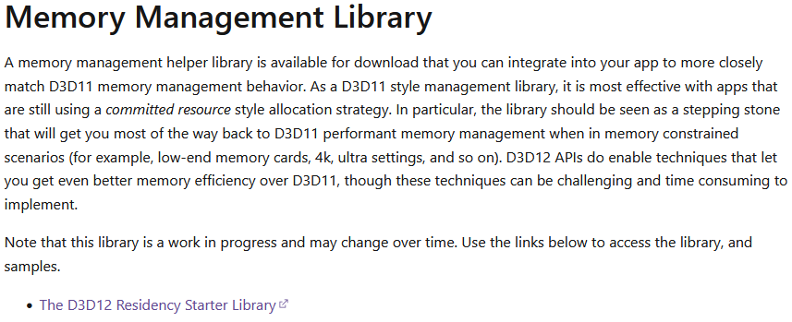

-This is useful to having a library that allocates memory for the GPU.

<https://github.com/Microsoft/DirectX-Graphics-Samples/tree/master/Libraries> (D3D12 residency starter library)

**This page has all the useful librarys:**

<https://learn.microsoft.com/en-us/windows/win32/direct3d12/directx-12-programming-environment-set-up>